**Al Salem Johnson Controls (York)**

**C:\Users\Ashraf\Desktop\ASJCILOGO_web.pngWebsite, E-commerce and Mobile Application Project**

**Business Requirements Document**

V1.1

**Prepared By**





**Ref #:** JC004001BRD3618  
**Date**: 3rd June 2018 **Last Updated**: 12th June 2018

Saudi Arabia, Jeddah

Tel: 966-12-6574201

Fax: 966-12-6523098

**Table of Contents**

[1 Executive Summary 5](#_Toc516580641)

[1.1 The Project 5](#_Toc516580642)

[1.2 The Engagement 5](#_Toc516580643)

[1.3 Document Audience 5](#_Toc516580644)

[2 Website Business Requirements 6](#_Toc516580645)

[2.1 Site Structure 6](#_Toc516580646)

[2.2 Applications Forms 9](#_Toc516580647)

[2.3 Landing Pages 10](#_Toc516580648)

[3 E-Commerce Site Business Requirements 12](#_Toc516580649)

[3.1 E-Commerce Site Features 12](#_Toc516580650)

[3.2 Payments & Delivery Process 13](#_Toc516580651)

[4 Mobile Application Business Requirements 15](#_Toc516580652)

[5 Integration 18](#_Toc516580653)

[6 Johnson Controls Approval 19](#_Toc516580654)

**Revision Information**

|  |  |  |  |
| --- | --- | --- | --- |
| Ver # | Author | Date | Comments |
| 1.0 | Ashraf Hasan | 3rd June 2018 |  |
| 1.1 | Ashraf Hasan | 12th June 2018 | Add new sections for landing pages and integration with minor updates for e-commerce features |
| 1.2 |  |  |  |
| 1.3 |  |  |  |
| 1.4 |  |  |  |

**Terms**

|  |  |
| --- | --- |
| Term | Description |
| Website | The official web site of Johnson controls (York) |
| E-Commerce | The online store where you can buy (York) products |
| Mobile application | The Mobile application version of the store |
| CRM | Microsoft Dynamics CRM On-Premise (Dynamics 365) |

# Executive Summary

## The Project

Al Salem Group of Companies in Saudi Arabia hold the reigns as the biggest supplier of air conditioners in the region and would like to improve their website, enhance their e-commerce and publish new mobile application to encourage and reach more customers.

## The Engagement

A meeting was conducted between Netways and Al Salem (York) team to discuss the business requirements of the website, e-commerce and the mobile application, in addition to get the requirements of the backend system and how these systems will interact together to serve their customers.

## Document Audience

The main intended audiences for this document are:

* Johnson Controls Business Owner
* Johnson Controls Marketing Team
* Johnson Controls Customer Care Department
* Johnson Controls Project Manager
* Johnson Controls Project Sponsor

# Website Business Requirements



The website has two types of pages, normal content pages and application pages and supporting English and Arabic languages. Netways will apply current website design to the new website and prepare the required page layouts so Johnson Controls content team can start creating and publishing their contents.

## Site Structure

Site structure is as below:

|  |  |  |
| --- | --- | --- |
| Page | Description | Comments |
| Home | Home page of the site |  |
| * About Us | Heading Navigation |  |
| * + Company Profile | Normal Content Page |  |
| * + Why YORK? | Normal Content Page |  |
| * + Management Team | List of employees with (Image, Name and Job title) | Read more button to get short description about the staff |
| * + Our Projects | List of projects with their image | Image gallery style |
| * + Our Clients | List of clients logo |  |
| * Media Center |  |  |
| * + News | List of news items including (Title, Date and short description) | Read more button to redirect to the news details |
| * + Technical Articles | Article page with title, picture and short description | Read more button to redirect to the details page with contact us button |
| * + Media Gallery | Consists of Images and video galleries | Each gallery open in a popup windows where you can browse different images or videos |
| * + Media Contact | Normal Content Page |  |
| * Careers |  |  |
| * + Working With Us | Normal Content Page |  |
| * + Our People | List of employees with (Image, Name and Job title) | Read more button to get short description about the staff |
| * + Development Programs | List of programs with images and titles | Read more button to get short description about the staff |
| * + Apply For Jobs | Normal Content Page | Has external link for employment |
| Residential | Has three main sections for Applications pages | Each application page has a short description with a list of products |
| * AC Products | A page contains list of products (Window AC, Hi Wall Split, Free Standing, Ceiling / Free, Cassette, Ducted Split, Packed, Thermostat) | There is a product details page for each product |
| * Showroom Dealer Locator | A page with google map locator | The page contains filter options based on (type, region and city) |
| * Smart Homes | Content page with two tabs (Home Automation and Security Solutions) | Each page has a download brochure button and Call Back Request |
| * Replacement Parts | Normal Content Page |  |
| * Service | Application page to send an inquiry to the concern department | Form include (First name, Last name, Email, Mobile, Region, City, AC Type, No Of Units, Comments) |
| * Warranty Registration | Application page to send an inquiry to the concern department | Form include (First name, Last name, Email, Mobile, Region, City, Dealer, Purchase Date, Model No, Serial No, Comment) |
| Commercial | Heading Navigation |  |
| * HVAC Products | A page contains list of products (Commercial Free Standing, Commercial Ducted Split, Commercial Packaged, Chilled Water Systems, Air Side Products, Thermostat and VRF) | There is a product details page for each product |
| * Allied | Normal Content Page | Has a call back request form |
| * Refrigeration |  |  |
| * + Sabroe | Normal Content Page | Has a call back request form |
| * + Frick Products | A page with list of items | Has a category filter options |
| * + York Solutions | Normal Content Page |  |
| * Rental Solutions | Normal Content Page |  |
| * Service | Application page to send an inquiry to the concern department | Form include (First name, Last name, Email, Mobile, Region, City, AC Type, No Of Units, Comments) |
| * Smart Buildings |  |  |
| * + Building Management Systems | Normal Content Page | Has a call back request form |
| * + Security Solutions | Normal Content Page | Has a call back request form |
| * Replacement Parts | Normal Content Page |  |
| Efficient Buildings | Normal Content Page |  |
| * Smart Homes |  |  |
| * + Home Automation | Normal Content Page | Has a call back request form |
| * + Security Solutions | Normal Content Page | Has a call back request form |
| * Smart Buildings |  |  |
| * + Building Management Systems | Normal Content Page | Has a call back request form |
| * + Security Solutions | Normal Content Page | Has a call back request form |
| Aftermarket Services | Normal Content Page | Has a call back request form |
| * Maintenance | Normal Content Page | Has a call back request form |
| * Upgrades | Normal Content Page | Has a call back request form |
| * Value Added Solutions | Normal Content Page | Has a call back request form |
| * Replacements | Normal Content Page | Has a call back request form |
| * Rental Solutions | Normal Content Page | Has a call back request form |
| * Replacement Parts | Normal Content Page |  |

## Applications Forms

The website has some applications forms to communicate with Johnson Controls (by email) on specific subjects as below:

|  |  |  |
| --- | --- | --- |
| Service Name | Description | Fields |
| Service Request Form | Submit an inquiry to Jonson Controls Call Center | * First Name * Last Name * Email * Mobile * Region * City * AC Type * No of Units * Comments |
| Warranty Registration Form | Submit an inquiry to Jonson Controls Call Center | * First Name * Last Name * Email * Mobile * Region * City * Dealer * Purchase date * Model No. * Serial No. |
| Contact Us | Submit an inquiry to Jonson Controls Call Center | * First Name * Last Name * Email * Mobile * Region * City * Interest Area * Comments |

## Landing Pages

The landing page has a form to be filled by the visitor and an email will be send to the concern department to notify them. Below are the type of landing pages used in the website:

1. Residential & Light Commercial
2. Aftermarket
3. Engineering Systems, Controls & Security
4. Industrial Refrigeration
5. Recruitment
6. Refrigeration

The landing page will use the below page schema:

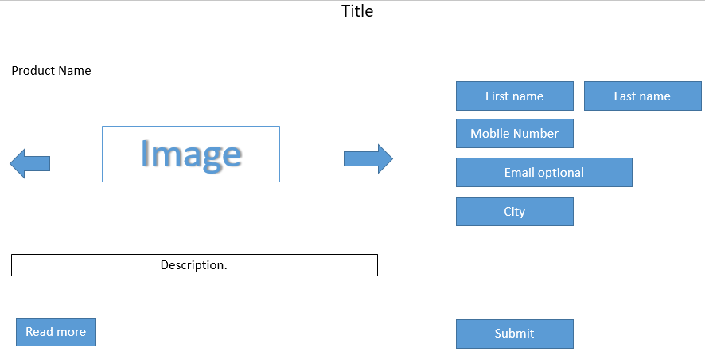

# E-Commerce Site Business Requirements

E-commerce site is the site where Johnson Controls can sell their products to customers. It‘s consist of two main sites (Backend and Frontend). The backend site also refers as a (Store) where Johnson Controls concern departments can manage their products, orders, payments, shipping …etc. The frontend site will be the interface for the customer to purchase (York) products and follow his orders.

## E-Commerce Site Features

E-commerce site will include the below features:

* Registration form: including (First Name, Last Name, Email, Company name, Password and Confirm Password)
* Login Form
* Products categories has the below two levels:
  + Window AC
    - TAURUS
    - Millennium
  + Split AC
    - ICEBERG
    - FROST
* Product list page: contains (Product image, Title, Price and Add to Cart button)
* Filter products by (Price, BTU, AC type, Coverage Area)
* Product details page, having the below details:
  + More product pictures
  + 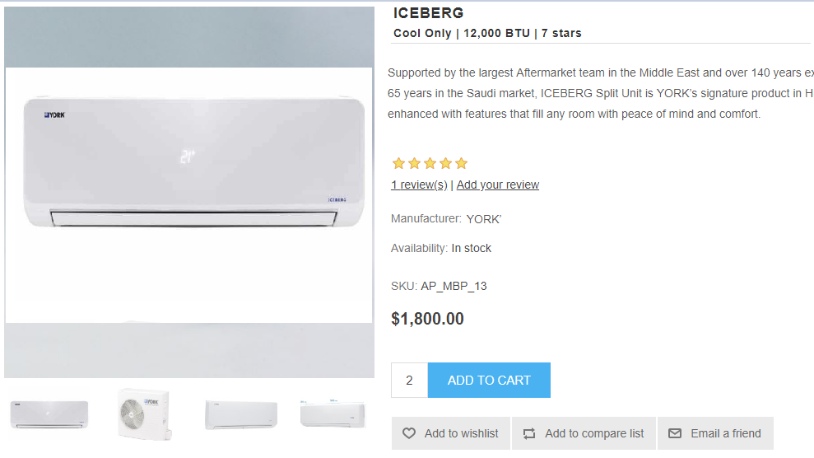Product Attributes
  + SKU
  + Reviews
  + Star Rating
  + Price
  + Add to Wish list / Add to Compare list / Email a Friend
  + Social media bar to share a product with your friends
  + Product tags
  + Related products
  + Number of items in stock
  + Availability (In stock, out of stock)
* Shopping cart
* Discount Code flexibility: per product / per customer / per quantity and N times features.
* Stock management. The inventory management allows store owners to discern physical stock and available quantities. You can easily manage the order status for each product, manage products, manage reviews, prices and taxes.
* Product comparison: Comparing products side by side
* Shipping details to include customer details:
  + First name
  + Last name
  + Email
  + Phone
  + Street address
  + Country
  + City
  + District
  + Additional information
  + Google map to locate the exact location
* Notify store manager for low stock quantity

## Payments & Delivery Process

Netways will apply the same payment module currently used by Johnson Controls. Below is the flowchart of the full cycle of purchasing a product from the e-commerce site till deliver and install the product.

|  |  |
| --- | --- |
| Task | Actions |
| Select Product | Login to the store site, select your products and add them to the cart |
| Select Payment Type | Select the Payment type (Master, Visa or SADAD if available) |
| Order Confirmation | Redirect to thank you page with order number, the customer will receive an email also from CRM\*. |
| Start Internal Process | A concern department will be notified, so they can start internal process |
| Deliver & Install | Finalize the order delivery and installation |
| Close the Order | Update the order status and close it |

\*The email templates will be customizable through Microsoft Dynamics CRM for the customer and the concern department that will initiate the internal process.

# Mobile Application Business Requirements

This is will be the mobile application version of the store, where customer can use it to purchase Johnson Controls (York) products. The mobile application will support IOS and Android operating systems. The mobile application will include the below features:

* Dashboard/Homepage
  + Banner: Showing product images as banner images
  + Categories: Showing categories in grid view
  + Featured Products: Showing Featured Products in grid view
* Navigation
  + Navigation menu
  + Top menu
    - App Name
    - Search button: Regular search
    - Cart button
    - Sign In Or Sign Out
    - My Account
    - Address
    - My Order
    - WishList
    - Setting
* Categories
  + All Product Categories in Multiple Label
* Product List - Category wise
  + Product list in gridview
  + Filter - attribute and option wise
  + Sort
    - Alphabetically ascending/descending
    - Price
    - Created On
* Product details
  + Image banner
  + Quantity selector
  + Attribute selector (Ex: Size, Color)
  + Description
  + Add to cart button
  + Add to wishlist
  + Related Products
* Wish List
  + Selected categories in list view
* Address
  + Edit & Delete Address
  + Create New Address
* My Order
  + Order Details
* My Account
  + Edit Account
* Cart
  + List of products added to cart
  + Add/remove product from cart
  + Increase/decrease product quantity
  + Add coupon
  + Check out
    - Shipping address
    - Payment method
    - Order review in table view
  + Place order
  + Back to the Home Page.

In addition to the above e-commerce features, the mobile application will provide the below services for the customers:

1. Case Request:
   1. First Name
   2. Last Name
   3. Email
   4. Mobile
   5. Region
   6. Description
   7. City
2. Complaint Request:
   1. First Name
   2. Last Name
   3. Email
   4. Mobile
   5. Region
   6. Description
   7. City

# Integration

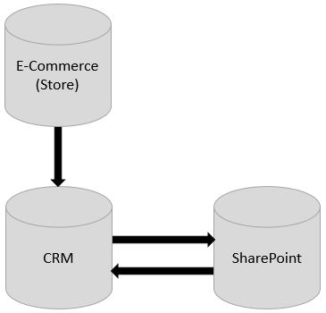

The figure above shows how the systems is working together to serve the employees, visitors and customers:

* **E-commerce (Store)**: after the payment process, a new record will be send to CRM, then a notification will be send to the customer and the concern department.
* **SharePoint**: will be the interface for the end user. The user will open the required service and submit his request, the request will be save in CRM for internal process and notifications
* Netways will deliver a training session for one of the services on How to integrate SharePoint and CRM so the JCI technical team can continue developing the remaining services

# Johnson Controls Approval

Based on the information provided in this Business Requirements Document dated 3rd June 2018 we agree that all requirements provided to Netways have been included in this document

**Approved by:   
*Al Salem Johnson Controls (York) – Project Manager***

Signature Title

Name Date

**Approved by:   
*Netways – Project Manager***

Signature Title

Name Date